# ElderNet of Lower Merion and Narberth

# Team 3

# 3/30/2022

## Contributors

We would like to thank the other teams for their valuable help in understanding and cleaning the data. We would also like to thank the R-Ladies and DataPhilly organizers for leading this event. Finally, our sincere thanks to ElderNet for providing their data and guidance throughout the project.

* Michael Bryan
* Lasaly Changkachith
* Cara Cuiule
* Zane Dax
* Jamaal Green
* Michael Holt
* Alisha Paul
* Dave Slinger

## Executive Summary

The results in this report reflect functional observations and visualization. The granularity and quality of the data shared do not support statistical inference, so the results here should be treated as suggestions and worth future effort.

Observations:

* Geography matters. ElderNet’s service delivery and donations are local to ElderNet’s office in Bryn Mawr. Demographic data can contribute to a location model. Such a model on current service areas would assess wider geographies for potential need.
* Median Household Income, Population of 55+ and Population with Disabilities are appropriate measures for a location model.
* Philadelphia, Quakertown (18951), Pottstown (19464) and Coatesville (19320) areas have potential as future locations.
* Small donations add up. 50% of donations are made from amounts less than $10,000.
* Donations had a lot of variation and are very difficult to forecast, currently reflecting 1 sample pre-pandemic and the 2 pandemic years.
* Donations are related to median household income from Census data sources. This relationship is modest.
* Eldernet’s donation data, making it difficult to forecast.
* Some data relationships are likely to change due to the pandemic. It has affected data collection including the national census. Donations, care management, volunteer services and other personal interactions were affected. The isolation and economic impact on the elderly is yet to be measured. These factors also complicate forecasting.
* Publications by federal, state and county level include surveys, budgets and counts of social services delivered. While their data is limited, these sources provide trends and service definitions against which Eldernet can compare its own offerings.
* Comparing ElderNet’s services to public services suggests the potential for ElderNet service growth.
  + Homebound services including meals and caregiving.
  + Activity services like Senior Centers & Adult Day Care.
  + Health services for wellness, Medicare and prescriptions.
  + Financial support with taxes, insurance and social security.

## Prompts

This study pursued the following prompts from ElderNet, recommending actions for its future and general growth interest:

1. Are there areas of need that ElderNet should focus on in the future? (e.g. you can use Census data to provide an in-depth picture by county/ZIP Code of the population, and their likely needs)
2. Explore ElderNet's growth with regard to number of clients, donors/donation amount, etc.
3. Any other analyses you think would be interesting to do/helpful to ElderNet to better understand their data

## Data

The following material may be duplicative with other teams, but necessary here to allow this report to stand alone. Each of these assets have applications in the prompt sections below..

### ElderNet’s Anonymized Client, Service and Donations Data

ElderNet initiated this study offering data files on clients, services and donations which were anonymized to protect client identities. These files included:

* ***client_info_anonymized.csv*** includes basic de-identified demographics on clients.
* ***care_management_anonymized.csv*** provides information on clients' interactions with ElderNet Social Workers.
* ***volunteer_services_anonymized.csv*** offers information on rides provided by ElderNet volunteers
* ***pantry_anonymized.csv*** collects a history of clients' visits to ElderNet's food pantry
* ***donations_anonymized.csv*** shows donations made in support of ElderNet's activities

### ElderNet’s Client Counts by Service and ZIP Code

Subsequent to the study’s initiation, ElderNet summarized client counts by ZIP Code to support geographic modeling. The file named ***aggregated_numbers.md*** shows the number of clients engaging Eldernet by service and by ZIP Code.

### 

### U.S. Census Bureau Sources

The US Census Bureau publishes its major Decennial estimates every decade. This is required by the U.S. Constitution for apportioning seats in the House of Representatives. With each Decennial, the Census also updates the delineation of Census geographies including Tracts, Block Groups and Blocks. These geographies are contained with counties and states. The publication of geographic shapes is called the TIGER/Line.

* On a rolling basis, the Census publishes the American Community Survey (ACS) with 1 Year and 5 Year estimates. The most recent 2019 vintage of the ACS 5 Year estimates was used in this analysis.
* Consolidating data by ZIP Code is expeditious, but these geographies do not directly support demographic data. The US Postal Service defines ZIP Codes to manage efficient routes for mail carriers which can span counties. The Census Bureau converts ZIP geographies to ZIP Code Tabulation Areas (ZCTA) for demographic data publications.

### 

### Other Sources from Federal, State and County Agencies

Additional public reporting was found by simple internet searches from the following agencies:

* U.S. Department of Health & Human Services, Department on Aging
* National Institutes of Health, National Institutes on Aging programs
* Pennsylvania Department on Aging
* Montgomery County Office of Senior Services

### 

### Applied Technologies

The study’s presentation and final report relied on these technologies:

* R and R Studio using pacman, mapsf, tidycensus, simplefeatures, tigris, tidyverse
* Python and Jupyter using pandas, geopandas, matplotlib, seaborn, plotly
* QGIS is a desktop GIS tool
* Streamlit is used for interactive mapping

## Results

### Prompt 1: Future Focus

#### Insight from Census Data

ElderNet’s current service delivery reflects the locality of its office in Bryn Mawr, PA. Both client counts and donation volumes are highest near the office and dissipate with distance from Lower Merion. It is appropriate to apply location model concepts, where future areas’ service would be predicted by current service delivery related to demographic data. The figures below visualizes this location based business with darker Zip Codes having the majority of services activity.

**ElderNet’s Client Counts by Zip Code:**

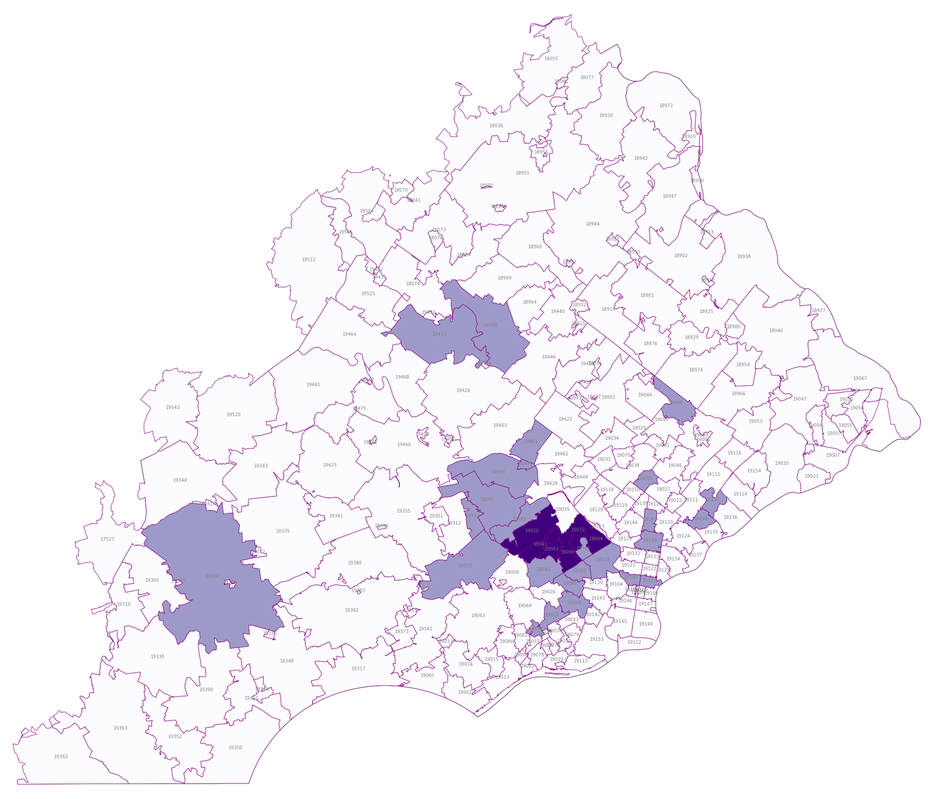

The Team attempted to build such a model statistically. This effort began by casting ElderNet’s service counts by Zip Code on to Census geographies called Zip Code Tabulation Areas (ZCTAs). The effort then defined ElderNet’s current service area to include ZCTAs adjacent to those currently served. A predictive model on this service area definition would be applied to wider areas to assess their potential for service needs. It would also be applied to estimate need for each regional county, valuable for justifying ElderNet’s public funding.

Logically, the model effort sought a subset of the 2019 ACS dataset’s 36,000 variables including total population, population over 55 years of age, population with disabilities and median household income. Analytically, the logistic regression algorithm was applied. The training effort did not find strongly significant relationships of any of these variables and ElderNet’s service variability. The lack of significance suggests that some basic assumption is incorrect. Either ElderNet is not serving these populations or that its level of service does not reflect each geography’s need. The latter conclusion is most reasonable.

#### Geographic Growth

As a result, ElderNet should still pursue these predictive variables in their growth planning. From the Census ACS 5 year data, Total population, Median Household Income, Population over 55 and Population share with disabilities are the primary demographic metrics for evaluating an area’s potential for service.

### 

### 

### 

By observation of the maps provided above, the city of Philadelphia shows concentrations of need in every variable. West Philadelphia in particular has both need as well as proximity to ElderNet’s office. Philadelphia also has its own budget including funds directly from federal sources. Unless there are known constraints, the city would be a logical growth location.

Outside the city there are ZIP Codes with both low income and population density that should be assessed as potential next locations for Eldernet. These would include

* Eastern Delaware County including Darby (19023)
* Central Montgomery County including Norristown (19404)
* Western Montgomery County including Pottstown (19464)
* Central Chester County including Coatesville (19320)

#### Other Public Data Sources

In addition to the Census, ElderNet can take advantage of public datasets now required by their original funding and the Open Government Data Act (2018). These data projects have national scope with a sampled survey basis. As a result, they do not have the detail to support data appending at the ZIP Code or client address level as the ACS does. With their reports, they can be used to anticipate changes in aging needs as well as service definitions. Most consistently these publications forecast that elderly population is growing faster than the total population as Baby Boomer age and healthcare extends life expectancy. They include:

* The National Survey of Older Americans Act Participants (NSOAAP) published by the Aging, Independence, and Disability (AGID) Program within Administration for Community Living (ACL). https://agid.acl.gov/
* Research publications sponsored by the NIH’s National Institute on Aging:
  + National Archive of Computerized Data on Aging (NACDA) from the University of Michigan
  + National Social Life, Health, and Aging Project (NSHAP) survey from the University of Chicago
  + National Health and Aging Trends Study (NHATS) also run by the University of Chicago as well as its supplement National Study of Caregiving (NSOC)
* The Commonwealth of Pennsylvania and local counties deliver services for aging adults and seniors funded by both local taxes as well as block grants from the federal programs.. The data from this public level is limited to budget and service counts.
  + - Pennsylvania Department on Aging provides reports <https://www.aging.pa.gov/publications>

Montgomery County’ Office of Senior Services includes statistics in its 4 Year Plan which are taken from the Census ACS 5 Year estimates discussed above.

<https://www.montcopa.org/DocumentCenter/View/29022/OSS-4-year-Plan>

* Public Health Management Corporation (PHMC) is a regional non-profit that serves the Philadelphia area and publishes the Community Health Data Base (CHDB). Access to this database requires registration and subscription fees. <https://research.phmc.org/products/community-health-database>

### 

### Prompt 2: Growth

#### Donation Forecasting

ElderNet’s donation data demonstrates a high degree of variation, combining regular small donations with those from the fall campaign and major one time contributions. These impacts cause advanced forecasting methods to lose statistical significance. A simple forecasting method, using averages and ranges, makes these impacts clear in the trend figures in Appendix 17.

The data demonstrate seasonal or cyclical patterns. The top donation yielding campaign drives by dollar amount were the Foundation, the Emergency Fund, and the Fall Township drives. Nearly 50% of money donated came from donations below $10,000. 70% of money donated came from donations below $25,000.

Using the ACS data discussed above, ElderNet’s donations show a significant correlation with local median household incomes. This suggests that donation campaigns may target affluent households, neighborhoods and high income corporations. This conclusion is probably shared by many non-profit organizations. Targeting would benefit, then, from other third party data sources that compile donor data by issues of interest.

#### Other Data Forecasting Observations

The other datasets provided by ElderNet provided the following observations (see Appendix 17 for graphs):

* **Volunteer Services** - Volunteer services dipped during pandemic, which makes sense as volunteer services were canceled/reduced for a significant period of time.
* **Care Management** - Care management generally decreased after the fall of 2020. Remote contact with and without the client were the two dominant categories within the dataset.
* **Pantry** - Pantry activity generally rises during holidays and also rose during the pandemic.

#### Suggestions for Future Data Collection

Predictive modeling would likely need more variables against local geographies over time not available to this effort. Some studies have investigated donations to non-profit organizations against variables such as income levels, age, years of education, religious participation levels, marital status, and income. See Ficklin (2014) as well as Meyer (2008). Possible variables that predict food insecurity in older adults are depression, financial issues, and past food stamp usage (Goldberg and Mawn 2014).

#### Growth in Range of Services Provided

Growing ElderNet services benefits from comparisons to public reporting on social services. These public reports first provide a basis of standardizing terms for each service. Aligning ElderNet’s service categories to these public definitions would help in communicating and coordinating public interactions including funding requests.

ElderNet’s services overlap with those provided by federal and county human services organizations as well as third parties with public funding. The catalogs of these existing services can be found in the Appendix.

* Pennsylvania’s Department of Aging funds county programs
* Counties then provide local social work. Montgomery County in particular delivers social services for Office of Senior Services https://www.montcopa.org/148/Senior-Services
* Catholic Social Services is contracted by the city of Philadelphia to provide a variety of programs for seniors. Funded by the city budget, it has public annual reports on services programs and the demand for each. https://cssphiladelphia.org/service-category/senior-services/
* PA 211 is another example of service for basic needs now contracted by Pennsylvania to the United Way. https://www.pa211.org/

Comparing ElderNet’s services to these public services suggests the following potential for ElderNet service growth:

* Provide or integrate with other, public services that meet basic needs. This would include food, housing, healthcare access and safety from abuse. ElderNet probably already does this, so it may translate to increasing the granularity of reporting in Care Management.
* Expand services to the homebound from transportation to meals, caregiving and caregiver support.
* Add activity services such as Senior Centers and Adult Day Care with dedicated vehicles and facilities.
* Include health services focused on wellness, Medicare (like MEDI) and prescription assistance (like PACE).
* Financial support services including state and federal tax, insurance, social security income and planning.

### Prompt 3: Other Analyses

Over the course of this study, several unrelated observations were found which may be valuable:

* While ElderNet serves Lower Merion primarily, it has clients in Chester, Delaware and Philadelphia counties. Each of these areas has potential for public funding and the geographic constraints that come with it.
* Care Management services and Pantry services appear correlated. There may be a functional reason that they rely on each other.
* First time rides peaked in 2015, and have been decreasing since then.
* Pantry services occurred more often before noon than after. This was not the case with rideshare services.
* As ElderNet develops a geographic view of donations, clients and services, interactive maps will be valuable.
* ElderNet maintains social media on Facebook today. It may benefit from sharing that same content to Instagram and Twitter to promote donations and volunteerism.

## Conclusions and Next Steps

The study material above suggests that Eldernet should consider:

* advancing its analytical maturity by investing in granularity and quality in its data capture.
* extending client data by using geocoding to relate client addresses to smaller Census geographies such as block groups.
* developing a location model to assess geographies for growth potential against population, median household income, proportion over 55 and proportion with disabilities.
* new locations in Philadelphia, Darby (19023), Norristown (19404), Pottstown (19464) and Coatesville (19320).
* defining their service categories and terminology consistently with those used by the Department of Health and Human Services and Pennsylvania’s Department of Aging.
* expanding their service offering to include:
  + Homebound services including meals and caregiving.
  + Activity services like Senior Centers & Adult Day Care.
  + Health services for wellness, Medicare and prescriptions.
  + Financial support with taxes, insurance and social security.
* targeting affluent households and geographies for fundraising with supplemental data from third parties and larger non-profit publications.
* using interactive map software to assess service activity geographically.

## 

## 

## References

U.S. Bureau of the Census, American Community Survey, 2019 American Community Survey 5-Year Estimates, Base Tables; generated by Jamaal Green; using the R library tidycensus API.

U.S. Bureau of the Census, TIGER/Line Shapefiles, 2019, using the R library tidycensus API and ftp files. <https://www2.census.gov/geo/tiger/TIGER2019/ZCTA5/tl_2019_us_zcta510.zip>

Ficklin, Elizabeth, "Charitable Donations: An Analysis Of The Differences In Donation Patterns By Income Level" (2014). All Theses. 2056. <https://tigerprints.clemson.edu/all_theses/2056>

Goldberg, Shari L. and Mawn, Barbara E., “Predictors of Food Insecurity among Older Adults in the United States” (2014). Public Health Nursing. <https://ogg.osu.edu/media/documents/sage/Goldberg%20et%20al%20week%206.pdf>

Meyer, Lauren, “Predicting Charitable Contributions”, University of Wisconsin - Madison, School of Business, Research Department, Spring 2008, <https://instruction.bus.wisc.edu/jfrees/jfreesbooks/Regression%20Modeling/BookWebDec2010/Writing/CharitableContributionsMeyer.pdf>

boodleAI, “Innovation at its kindest”, 2022, accessed at URL <https://boodle.ai/about/>

## 

## Appendix

### 

### Appendix 1: ElderNet clients by service and ZIP Code.

* ZIP Code 10130 reflects Manhattan. Its data will be treated as 19130 center city.
* ZIP Code 19005 does not exist, so its counts will be excluded.
* ZIP Code 19450 is used for PO Boxes. Its data will be treated as 19438 instead.
* NA ZIP Code counts reflect clients without addresses including the homeless served. It will be excluded from geographic models.
* Where counts are less than 10, a value of 5 is assumed.

| **ZIP** | **Total** | **Care**  **Management** | **Pantry** | **Volunteer**  **Services** |
| --- | --- | --- | --- | --- |
| 10130 | 5 | 0 | 5 | 0 |
| 19003 | 228 | 188 | 178 | 61 |
| 19004 | 29 | 26 | 16 | 5 |
| 19005 | 5 | 5 | 0 | 0 |
| 19010 | 129 | 87 | 98 | 25 |
| 19018 | 5 | 87 | 5 | 0 |
| 19040 | 5 | 5 | 5 | 0 |
| 19041 | 19 | 15 | 12 | 5 |
| 19050 | 5 | 5 | 5 | 0 |
| 19066 | 5 | 5 | 5 | 5 |
| 19070 | 5 | 5 | 5 | 0 |
| 19072 | 41 | 31 | 14 | 16 |
| 19073 | 5 | 31 | 5 | 0 |
| 19082 | 5 | 5 | 5 | 0 |
| 19083 | 5 | 5 | 5 | 0 |
| 19085 | 5 | 5 | 0 | 5 |
| 19087 | 5 | 5 | 5 | 0 |
| 19095 | 5 | 5 | 5 | 0 |
| 19096 | 79 | 67 | 19 | 34 |
| 19123 | 5 | 5 | 5 | 0 |
| 19131 | 5 | 5 | 5 | 0 |
| 19140 | 5 | 5 | 5 | 0 |
| 19141 | 5 | 5 | 5 | 0 |
| 19149 | 5 | 5 | 5 | 0 |
| 19151 | 5 | 5 | 5 | 0 |
| 19152 | 5 | 5 | 5 | 0 |
| 19320 | 5 | 5 | 0 | 0 |
| 19333 | 5 | 5 | 5 | 0 |
| 19401 | 5 | 5 | 5 | 0 |
| 19405 | 5 | 5 | 5 | 0 |
| 19406 | 5 | 5 | 5 | 0 |
| 19450 | 5 | 5 | 0 | 0 |
| 19473 | 5 | 5 | 0 | 0 |
| NA | 59 | 41 | 37 | 5 |

### 

### Appendix 2: Pennsylvania Aging Program Directives

<https://www.aging.pa.gov/publications/aging-program-directives/Pages/default.aspx>

| **Program**  **Area** | **Service** |
| --- | --- |
| 01 | AREA AGENCY ON AGING ADMINISTRATION |
| 02 | HOME-DELIVERED MEALS |
| 03 | CONGREGATE MEALS |
| 04 | SOCIALIZATION, RECREATION, EDUCATION & HEALTH PROMOTION |
| 05 | EMPLOYMENT SERVICES |
| 06 | VOLUNTEER SERVICES |
| 07 | PASSENGER TRANSPORTATION |
| 09 | LEGAL ASSISTANCE |
| 11 | INFORMATION AND REFERRAL |
| 12 | HOME HEALTH |
| 13 | PERSONAL CARE |
| 14 | PERSONAL ASSISTANCE SERVICES |
| 18 | MEDICAL EQUIPMENT, SUPPLIES & ADAPTIVE DEVICES |
| 19 | HOME SUPPORT |
| 20 | ADULT DAY SERVICES |
| 23 | CARE MANAGEMENT |
| 24 | PROTECTIVE SERVICES INTAKE AND INVESTIGATION |
| 25 | DOMICILIARY CARE |
| 29 | OTHER |

### 

### Appendix 3: Pennsylvania Department of Aging Services

<https://www.aging.pa.gov/aging-services/Pages/default.aspx>

Caregiver Support

Employment

Health & Wellness

Help at Home

Housing

Medicare Counseling

Legal Assistance

Meals

Ombudsman

PACE - Prescription Assistance

Protective Services

Transportation

### 

### Appendix 4: Montgomery County Adult and Senior Services

<https://www.montcopa.org/2889/Adults-Seniors>

| **ADULTS AND SENIORS** | **SENIOR SPECIFIC** |
| --- | --- |
| [Basic Needs](https://www.montcopa.org/2886/Basic-Needs)  [Community Health Programs](https://www.montcopa.org/3199/Community-Programs)  [Drugs and Alcohol](https://www.montcopa.org/2923/Drugs-and-Alcohol)  [Health and Wellness](https://www.montcopa.org/2924/Health-and-Wellness)  [Homeowners](https://www.montcopa.org/2919/Homeowners)  [Intellectual Disabilities/Autism](https://www.montcopa.org/1332/How-to-Access-Services)  [LGBTQ](https://www.montcopa.org/3349/LGBTQ-Health-and-Support)  [Mental Health](https://www.montcopa.org/2041/Adult-Mental-Health-Support-and-Services)  [Veterans](https://www.montcopa.org/3341/County-Benefits) | [Protective Services](https://www.montcopa.org/2830/Protective-Services)  [Adult Day Cares](https://www.alternativesforseniors.com/adult-day-care/)  [Advocacy/Ombudsman](https://www.montcopa.org/2832/Ombudsman)  [Family Caregiver Support Program](https://www.montcopa.org/2837/Family-Caregiver-Support-Program)  [Home Delivered Meals](https://www.montcopa.org/2836/Home-Delivered-Meals)  [Long-Term Care Facility List](https://www.montcopa.org/2447/Long-Term-Care-Facilities)  [OPTIONs Program](https://www.montcopa.org/2829/OPTIONS-Program)  [Senior Centers](https://montcopa.maps.arcgis.com/apps/webappviewer/index.html?id=3c2c0c043e524858ac2c94a03023802d)  Volunteer Program |

### Appendix 5: AGID Service Categories

U.S. Department of Health & Human Services, Aging, Independence, and Disability (AGID) Program

https://agid.acl.gov/DataFiles/NPS/

|  | **CATEGORY** | **SERVICE** |
| --- | --- | --- |
|  | **Access Services** | [Case Management](https://agid.acl.gov/DataFiles/NPS/Files.aspx?year=2019&serviceid=9)  [Transportation](https://agid.acl.gov/DataFiles/NPS/Files.aspx?year=2019&serviceid=8) |
|  | **Community Services** | [Congregate Meals](https://agid.acl.gov/DataFiles/NPS/Files.aspx?year=2019&serviceid=5) |
|  | **In-Home Services** | [Home Delivered Meals](https://agid.acl.gov/DataFiles/NPS/Files.aspx?year=2019&serviceid=4)  [Homemaker](https://agid.acl.gov/DataFiles/NPS/Files.aspx?year=2019&serviceid=6) |
|  | **Caregiver Services** | [Caregiver](https://agid.acl.gov/DataFiles/NPS/Files.aspx?year=2019&serviceid=1) |

### Appendix 6: Comparing ElderNet services to a public catalog

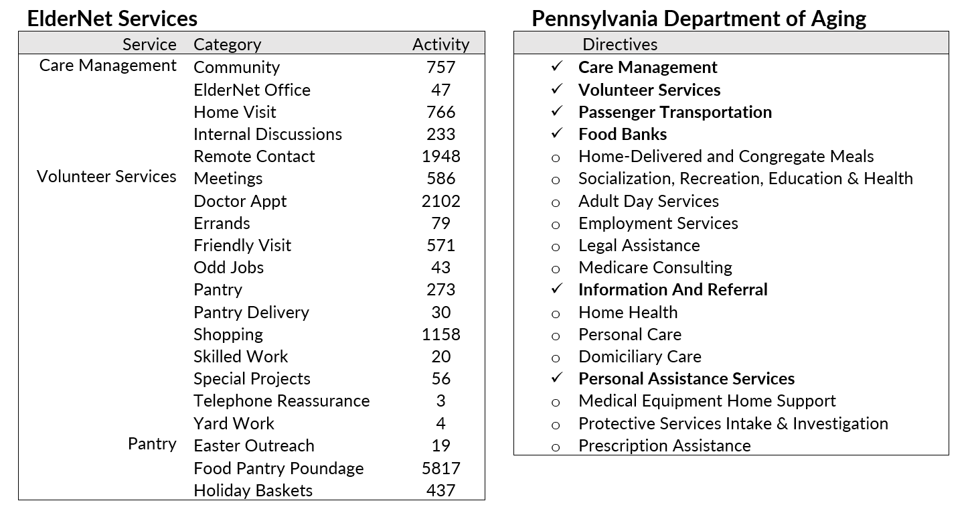

### Appendix 7: Donations 2019 Map

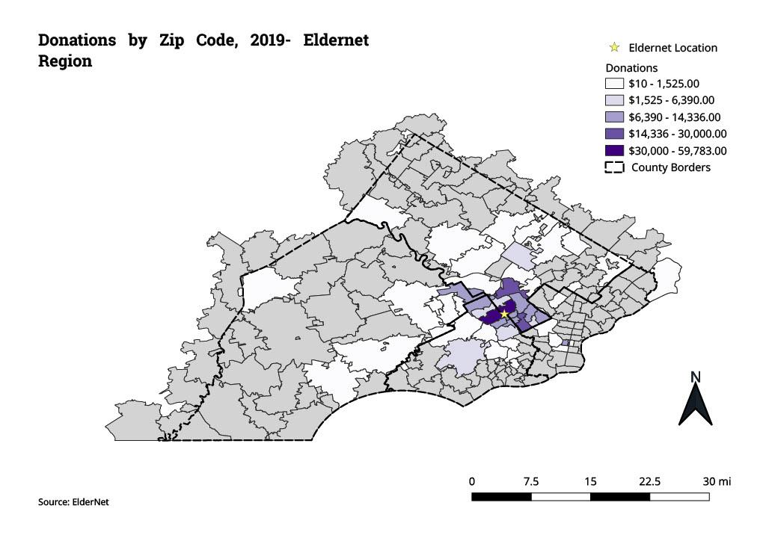

### Appendix 8: Donations 2020 Map

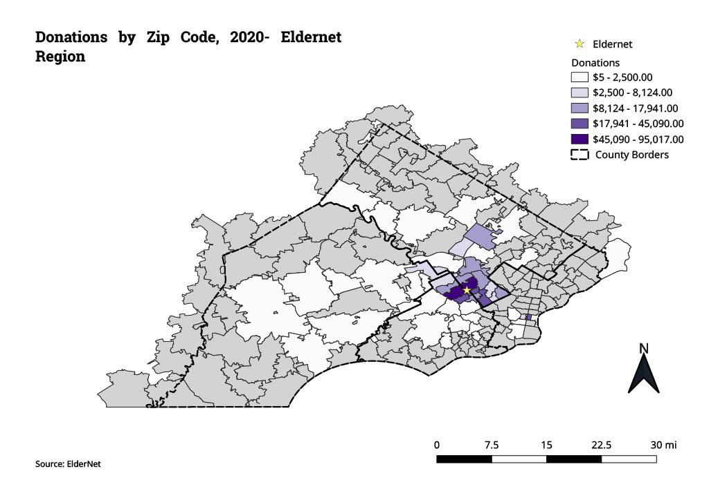

### Appendix 9: Donations 2021 Map

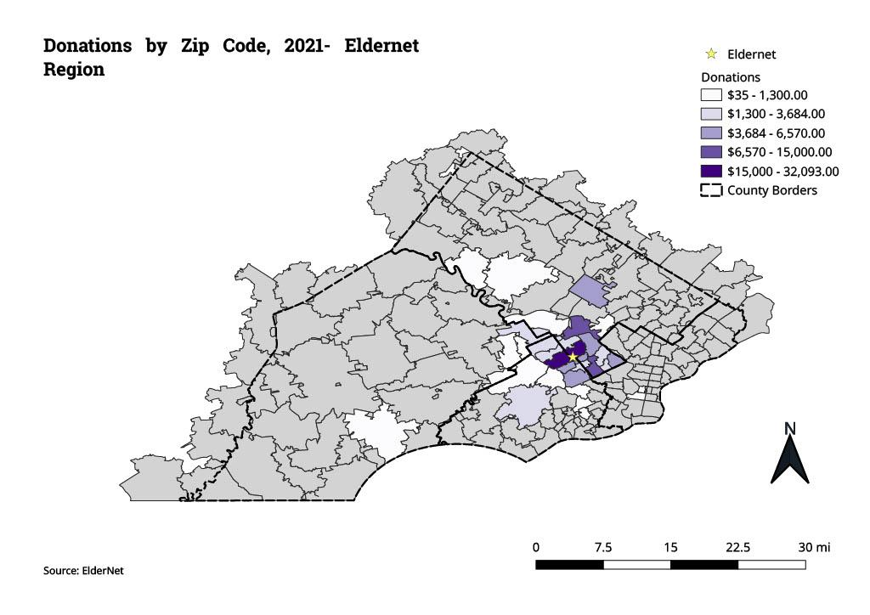

### Appendix 10: Median Household Income Map

### 

### Appendix 11: Population Over 55 Map

### 

### Appendix 12: Population with Disabilities and Over 55 Map

### 

### Appendix 13: Population with Disabilities

### 

### Appendix 14: ElderNet Service Area

### 

### Appendix 15: Total Population Map

### 

### Appendix 16: ZIP Code Reference Map with ElderNet Clients



### 

### Appendix 17: Data Forecasted with Mean, Range

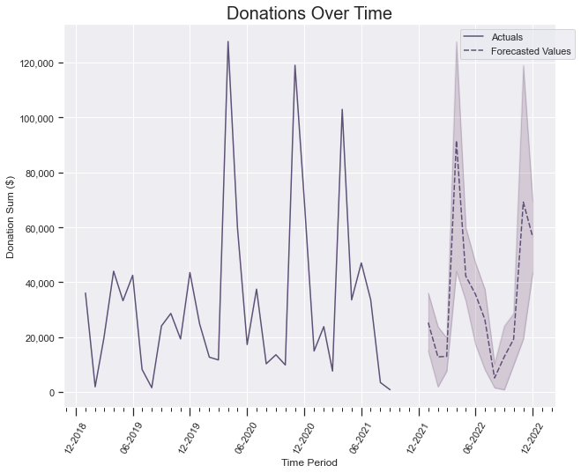

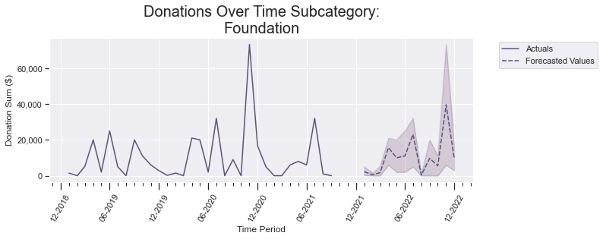

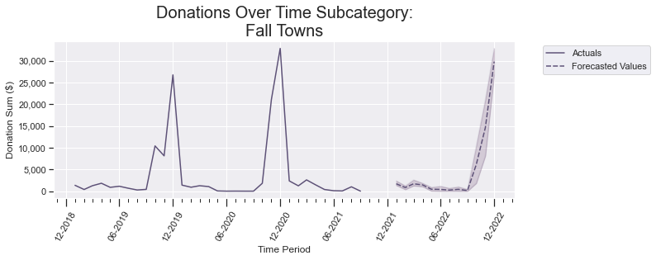

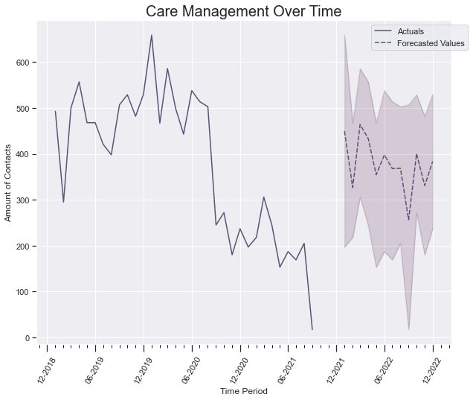

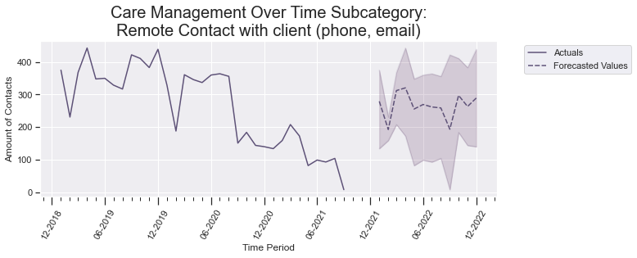

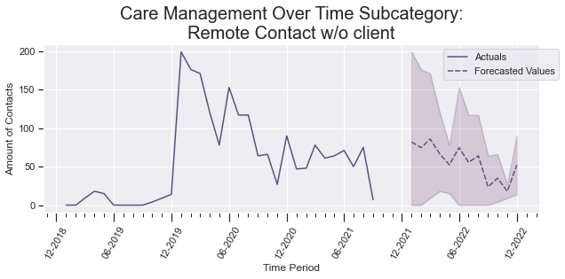

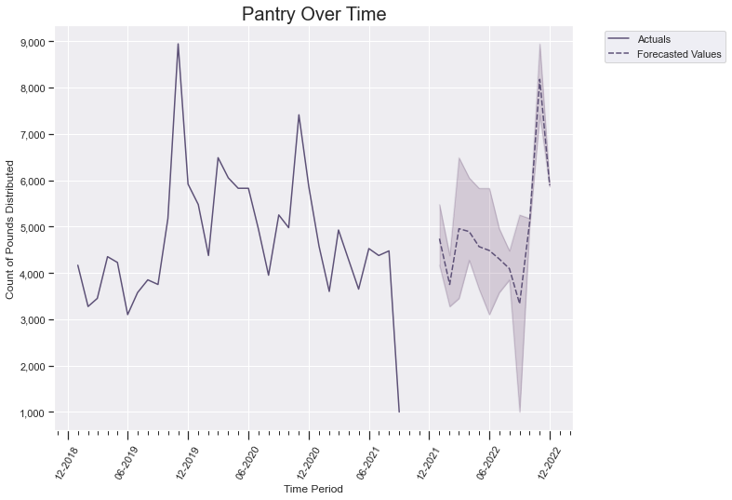

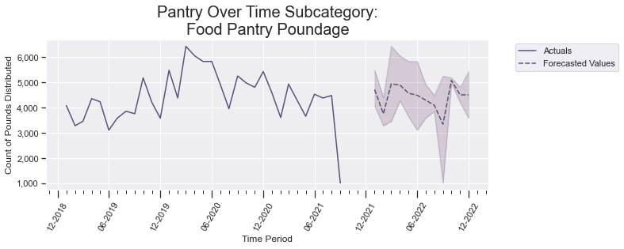

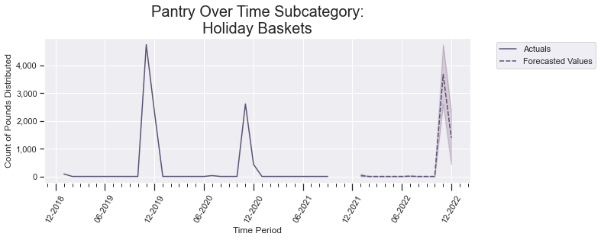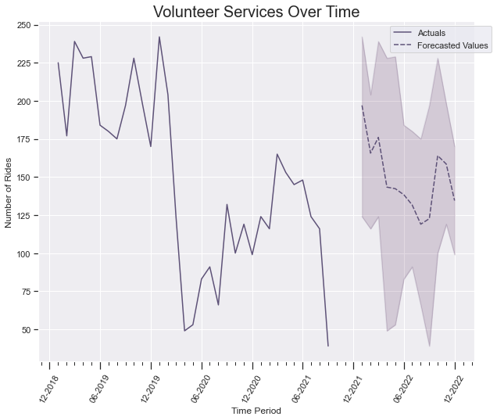

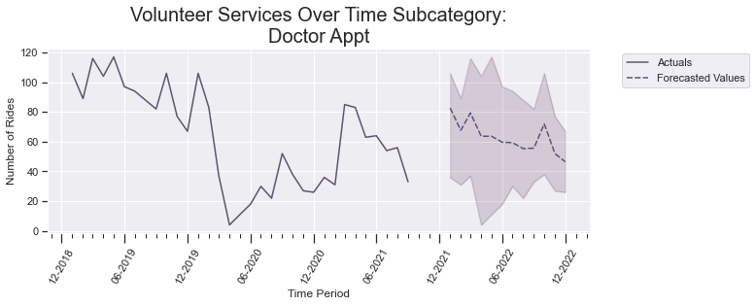

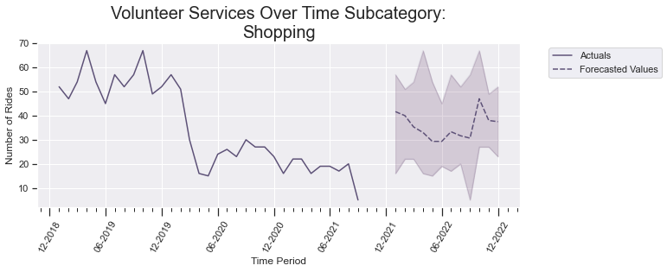

### Appendix 18: Cumulative Sum of Donations in Ascending Order

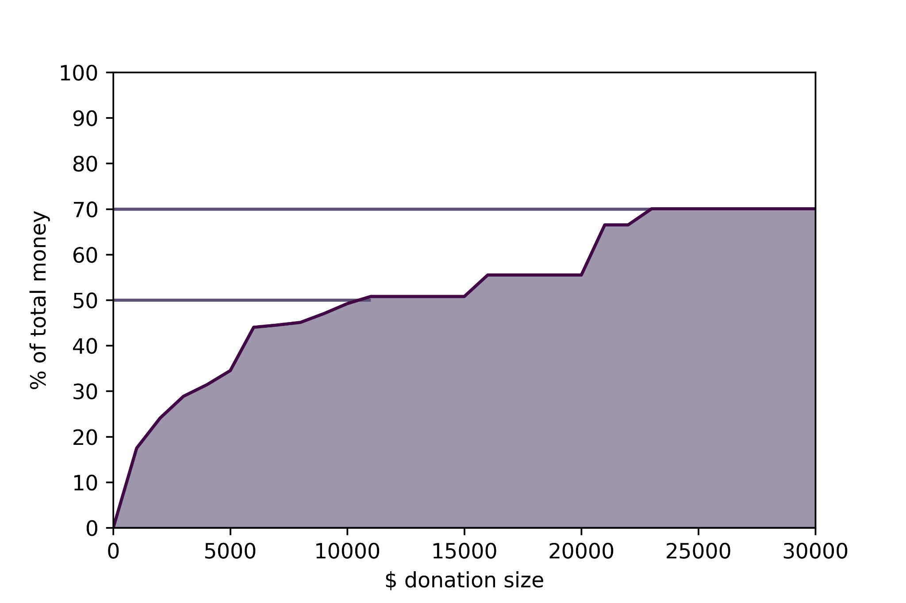

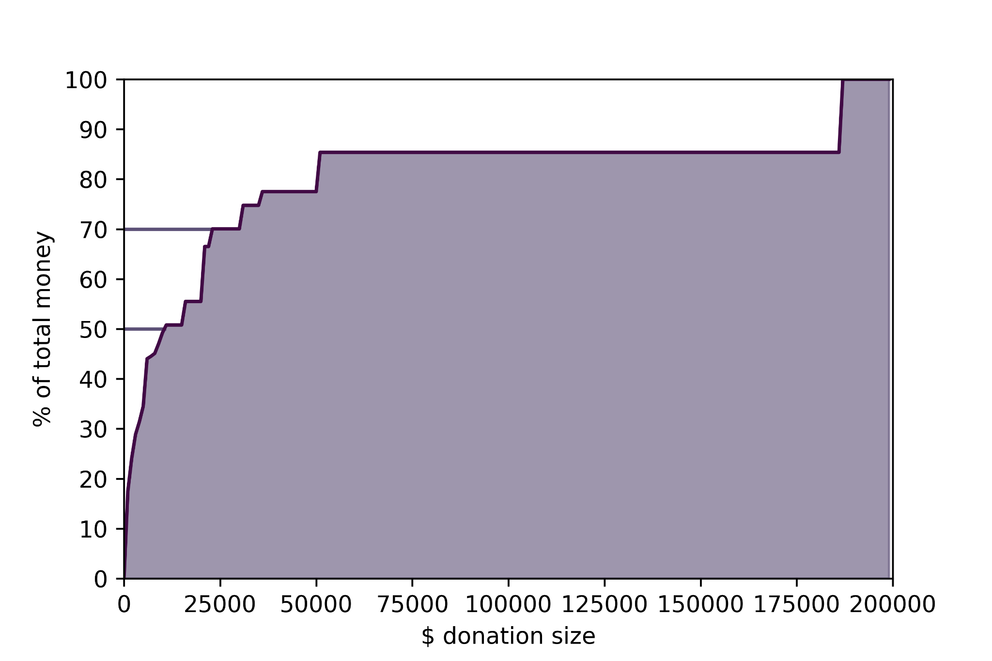

**Appendix 19: Heatmap of Events by Hour (pantry and community )**

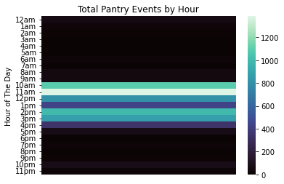

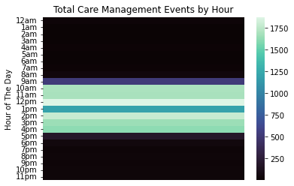

Overall Events by Hour

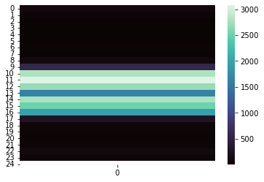

Event Counts by Type And Hour of Day



 